NATIONAL UNIVERSITY OF SINGAPORE
EXAMINATION FOR THE DEGREE OF
B.ENG. (ELECTRICAL) / B.ENG. (COMPUTER ENGINEERING)
(Semester II: 2003/2004)

EE4212 – Computer Vision
April 2004 - Time Allowed: 2 Hours

Instructions to Candidates:
1. This paper contains FOUR (4) questions and comprises FIVE (5) printed pages.
2. Answer all FOUR (4) questions.
3. Start each question on a fresh page.
4. All questions carry equal marks.
5 This is a CLOSED BOOK examination but candidates are allowed to bring in ONE (1) A4 sheet of paper.

EE4212 Computer Vision / Page 2

Q1.

A video camera is used for image acquisition. The image sensor is a 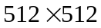 CCD array of size 6 mm x 6 mm consisting of 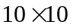 μm² photoelements. The focal length of the lens is fixed at 40 mm and the aperture setting is f/5.6. The lens is focused on a 0.5-m vertical post 5 m away.

(a) If the camera signal is digitised into a image, what is the size of the post (in pixels) in the acquired image?
(4 marks)

(b) Calculate (i) the angular field of view, (ii) the resolving power and (iii) the depth of field.
(9 marks)

(c) The camera is subsequently directed at a distant object. The lens is focused to infinity and the aperture adjusted to f/8.
(i) Is there any change in the angular field of view and the resolving power? Explain.
(ii) The image can be considered to be sharp for objects in the range 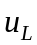 to . Determine .
(12 marks)

Q2.

(a) The intensity PDF’s of the background and object regions in an image can be approximated, respectively, by
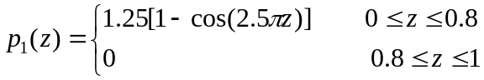
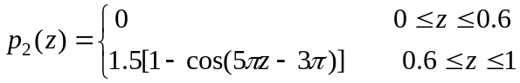
It is known a priori that the object region occupies 1/8 of the total image area.

(i) Sketch the PDF of the image.
(ii) Derive an equation that can be solved to give the optimum threshold. Simplify the equation as much as you can. (There is no need to solve the equation.)
(8 marks)

Q2 is continued on Page 3.
EE4212 Computer Vision / Page 3

(b) Show the results of the morphological operations:
(i) 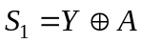
(ii) 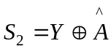
(iii) 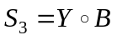
(iv) 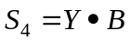
where denotes reflection,  dilation, erosion, opening, and closing. Y, A and B are as shown in the figure below. Y is a composite shape consisting of a rectangle R and a right-angled triangle T.
(10 marks)

(v) Suggest a purely morphological procedure that can be applied to obtain the positions of the centroids of R and T. A clear, illustrated explanation must be provided.
(7 marks)

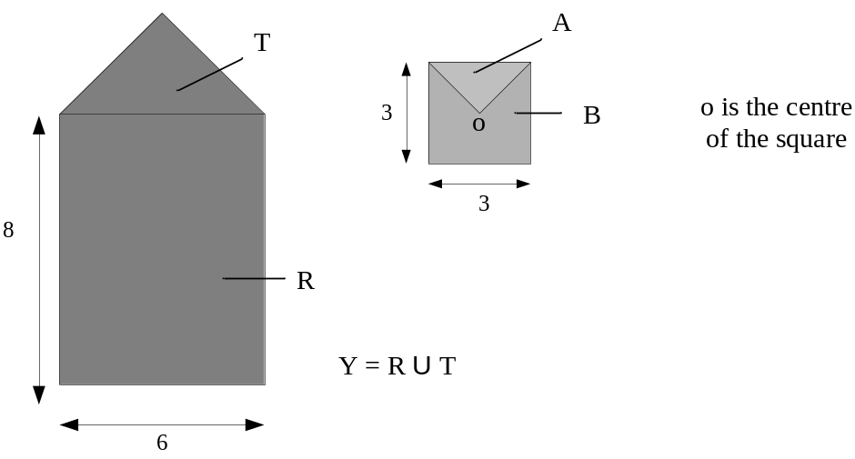
EE4212 Computer Vision / Page 4
Q3.

- A camera contains a lens with focal length 20mm and a 10mm × 10mm square CCD array divided into 500 × 500 square pixels. The pixel at the bottom-left corner of the CCD array has pixel coordinates (0, 0) and the principal point of the CCD array is at pixel coordinates (200, 200). Consider a point in the scene at camera-centered coordinates (0, 75, 500), given in mm, as shown in the following figure.

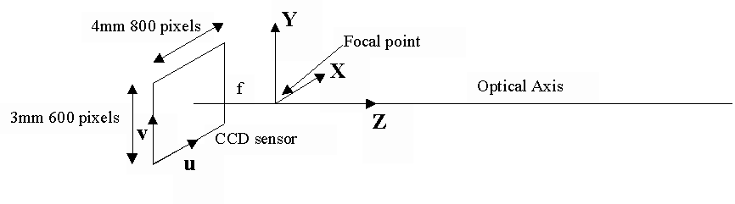
10mm, 500 pixels
10mm, 500 pixels
(200,200)
Optical axis
Focal point
CCD sensor
u
v

  - Give general equations (of the form u = ..., v = ...) that convert camera-centered image coordinates (x_{c}, y_{c}) into pixel-based coordinates (u, v). Define the terms used in your equations. Give also a specific numeric answer that specifies the pixel coordinates (u, v) of the scene point at camera-centered coordinates (0, 75, 500) under perspective projection for this camera configuration.
(8 marks)

  - What is the 3 × 3 camera calibration matrix, M_{int}, for this camera configuration?
(4 marks)

  - What image pixel would this scene point project to under orthographic projection using this set of camera parameters? Give the coordinates (in pixels) even if they are outside the 500 × 500 CCD array.
(3 marks)

- What is aperture problem? Does the aperture problem exist in general at corners?
(5 marks)

- What is the difference between the 2D motion field and the optical flow field?
(5 marks)

EE4212 Computer Vision / Page 5

Q.4

- Suppose the epipolar equation relating corresponding points in two images can be written linearly in the form Ax_{i}’ + B y_{i}’ + C x_{i} + D y_{i} + E = 0, construct the fundamental matrix F.
(5 marks)

- Show that for different points (x_{i}, y_{i}) and (x_{j}, y_{j}), the corresponding epipolar lines are parallel to each other and will differ only by an offset.
(5 marks)

- What is the minimum pair of corresponding points required to solve the unknown coefficients A, B, C, D, and E? Explain your solution.
(4 marks)

- What is an epipole in a stereo system? What does the epipole in image 1 tell you about the location of camera 2? What can you say about the epipolar lines of a collection of 3D points that all lie on the same epipolar plane?
(5 marks)

- Consider the following top view of a stereo pair of cameras:

Right image
Right optical
center
Left optical
center
Left image
f
f
45º

Draw the front views of the two 2D images and show the approximate positions of the epipoles and epipolar lines for this configuration of cameras.
(6 marks)

END OF PAPER

